Project Design Phase
Solution Architecture
Date | 03 October 2026
Team ID | SWTID-2026-7282
Project Name | Implement Client Script & UI Policy (Incident)
Maximum Marks | 4 Marks
Solution Architecture:
Solution architecture is a complex process – with many sub-processes – that bridges the gap between business problems and technology solutions. Its goals are to:
• Find the best technology solution to solve existing business problems.
• Describe the structure, characteristics, behavior, and other aspects of the software to project stakeholders.
• Define features, development phases, and solution requirements.
• Provide specifications according to which the solution is defined, managed, and delivered.
For this project, the architecture represents how an IT service desk user interacts with the ServiceNow Incident form. Client Scripts and UI Policies operate as parallel form-level controls to dynamically change field behaviour based on user actions and Incident conditions. The resulting field behaviour is visible immediately without requiring the form to be submitted.
Example - Solution Architecture Diagram:
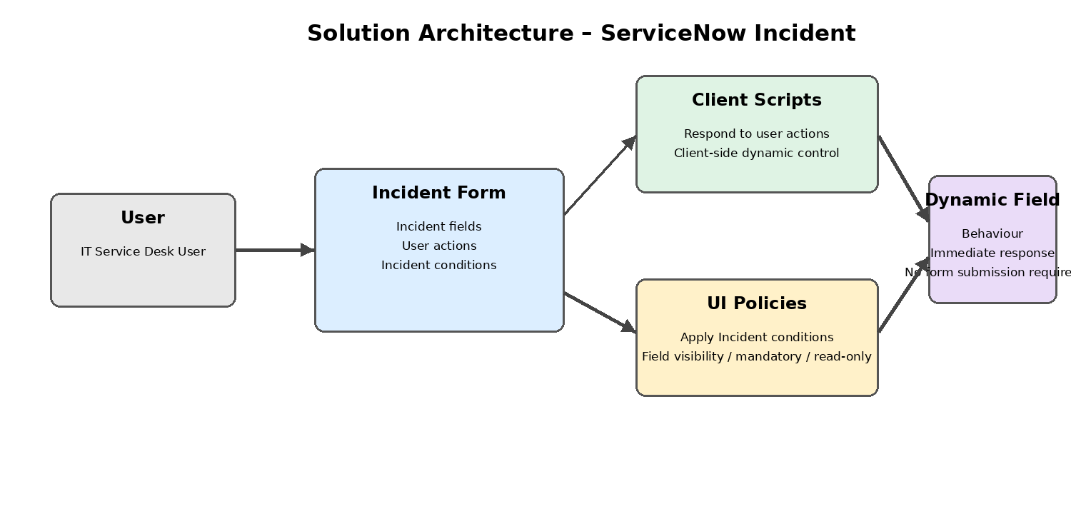
Figure 1: Architecture and data flow of the ServiceNow Incident Client Script & UI Policy solution
Reference: Project description supplied for the TNSDC project: Implement Client Script & UI Policy (Incident).

